|  |
| --- |
| Session 7 **Drawing Conclusions and Highlighting Significance of the Research**  **Giving an Academic Presentation (Poster Presentation Skills)** |

**Learning Outcomes:**

By the end of this session, students should be able to:

* write the Conclusion section with appropriate organizational structure and linguistic resources
* highlight the significance of the research using appropriate expressions and rhetorical strategies
* engage their audience through telling compelling research story, maintaining eye contact, and providing thoughtful responses during poster presentations
* design visually appealing posters that enhance understanding, utilizing principles of layout, color, and typography

**Writing the Conclusion section**

The conclusion section of a research paper is a crucial component that ties together the main findings and implications of your work. It serves as the final opportunity to reinforce your research's significance, offering a concise summary of key insights and their relevance to the field. A well-crafted conclusion not only synthesizes the main arguments but also highlights the broader impact of your research, suggesting avenues for future study and inviting further exploration of the topic. Mastering this section enhances the overall coherence of your paper and leaves a lasting impression on your readers.

|  |
| --- |
| **Warm-up Task** |

Find a partner and discuss the following questions.

1. What are the functions of the Conclusion section of a thesis and a journal article?

A backward-looking function:

* Stating the contribution of the research (How has it ‘filled’ the research space identified earlier in the thesis/research paper?)
* Identifying the limitations of the research (What gaps have you ‘left’ in the research space? What is it that we still don’t know?)

A forward-looking function:

* Making suggestions for further research (How could other researchers build on what you have done?)

1. What should be avoided in the Conclusion section of a thesis and a journal article?

* Straight repetition of statements already made
* Bringing new information not touched on
* Being too self-congratulatory in the contribution
* Being too self-critical in the limitations

|  |
| --- |
| **Task 1** |

Read and comment on the following two examples of the Conclusion section. Are they effective? Why/why not?

The abstracts below give you some ideas about the research.

Example 1:

|  |
| --- |
| **Abstract**  This article provides an overview of language learning strategies (LLS) for second and foreign language (L2/FL) teachers. To do so it outlines the background of LLS and LLS training, discusses a three step approach teachers may follow in using LLS in their classes, and summarises key reflections and questions for future research on this aspect of L2/FL education.  **Conclusion**  This paper has provided a brief overview of LLS by examining their background and summarising the relevant literature. It has also outlined some ways that LLS training has been used and offered a three step approach for teachers to consider in implementing it within their own L2/FL classes. It has also raised two important issues, posed questions for further LLS research, and noted a number of contacts that readers may use in networking on LLS in L2/FL education. In my experience, using LLS and LLS training in the L2/FL class not only encourages learners in their language learning but also helps teachers reflect on and improve their teaching. Many readers also find this to be the case.  Source: Lessard-Clouston, M. (1997). Language learning strategies: An overview for L2 teachers. *The Internet TESL Journal, 3*, 1-16. |

Suggested Answers:

This conclusion oversimplifies the message or topic of the research paper and looks no more intricate than an abstract. In fact, it sounds repetitive or list-like, which is additionally something that thesis/journal article conclusion should avoid. It is painfully short and does not push ideas forward. It is the type of conclusion writers produce when they have exhausted all other points. A conclusion should not just sum up.

Example 2:

|  |
| --- |
| **Abstract**  International management studies have been based primarily on the comparison of managerial behavior in countries around the world. Often, these studies have implied that business people behave similarly with their domestic colleagues as with their foreign counterparts. In questioning that assumption, this study tests whether intra-cultural behavior accurately predicts cross-cultural behavior. Using a negotiation simulation and a sample of 462 Japanese, American and Canadian businesspeople, behaviors in cross-cultural negotiations were found to differ in some important ways from those in intra-cultural negotiations.  **Conclusion**  [Para.1] Concisely stated, the central question of the study has been: Are negotiation processes and outcomes the same in cross-cultural interactions as in intra-cultural interactions? The study has considered six important negotiation constructs and tested for variation using four distinct cultural groups. Changes in behavior and outcomes have been observed in seven out of the twenty-four possible instances. The overall conclusion of the study therefore must be that negotiations do indeed adapt their behavior in cross-cultural interactions.  [Para. 2] The literature in cross-cultural communication indicates that cross-cultural negotiations will be more difficult than intra-cultural negotiations. Furthermore, research on reciprocity and interactional synchrony suggests that negotiators will imitate or reflect one another’s behaviors and thereby adapt to differing cultural situations. In two cases, such views are supported. There is only one finding that cannot be explained by established theory and that is why the Japanese negotiators were more attracted to Americans than they were to their fellow Japanese. It is conceivable that the phenomena appear to be more complex than our simple approach warrants.  [Para. 3] It is important to be aware of the limitations and shortcomings of the research design. Perhaps the most important consideration is the validity of the principal outcome measure, individual profits. Any laboratory experiment is open to criticism and this research is no exception. Additionally, much of the evidence supplied for accepting or rejecting hypotheses derives from participants’ self-reports and judgments, which in turn depend on memory and impressions. Future studies should include improvements in both these areas. The help of foreign researchers and the use of more inductive methods in foreign cultures will be needed to mitigate such limitations.  Source: Adler, N., & Graham, J.L. (1989). Cross-cultural interaction: The international comparison fallacy? *Journal of International Business Studies, 20*(3), 515-537. |

Suggested Answers:

The second conclusion makes a strong case for the writers as academics who have thought through their results and can present their argument in an integrated and effective manner – a summary of the study is provided along with the contribution of the study in terms of current knowledge. Limitations are also highlighted and suggestions given for further study.

|  |
| --- |
| **Task 2** |

**Rhetorical Moves in the Conclusion Section**

The Discussion/Conclusion sections model proposed by Hopkins and Dudley-Evans (1988)[1], Kanoksilapatham (2015)[2] and Swales and Feak (1994)[3] consists of seven moves:

|  |  |
| --- | --- |
| **Move 1** | Re-stating the focus of the study (purposes, research questions and hypotheses restated) (Obligatory) |
| **Move 2** | Stating selected findings (Obligatory) |
| **Move 3** | Making claims or generalizations (Conventional) |
| **Move 4** | Recommendation for practical application (Optional) |
| **Move 5** | Exemplifying (Optional) |
| **Move 6** | Limitations of the study (Conventional) |
| **Move 7** | Further research suggested (Conventional) |

* Note that not all the seven moves are obligatory.

The introduction to a thesis or a journal article places the research questions in context by moving from a wide to a specific focus. This specificity is retained throughout the paper until the conclusion. It is at this point that the content moves to a broader context again. See the diagram below.

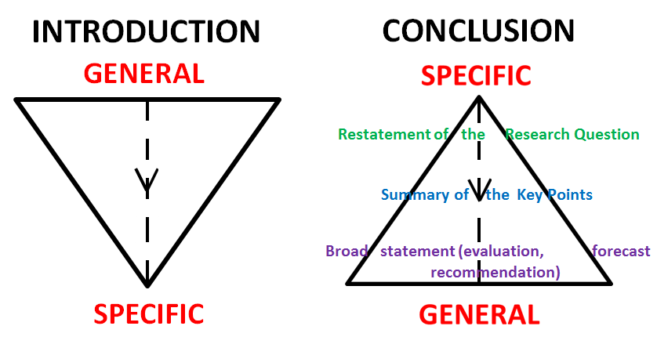

Read the Conclusion section of 2-3 journal articles of your field. Can you identify the moves stated in Task 2? Write down the moves in the table below. Compare i). the number and ii). the sequence of moves in the Conclusion section of the journal articles. Are they similar or different?

Share your findings with a partner.

|  |  |  |  |
| --- | --- | --- | --- |
|  | **Journal Article 1** | **Journal Article 2** | **Journal Article 3** |
| **Move 1** |  |  |  |
| **Move 2** |  |  |  |
| **Move 3** |  |  |  |
| **Move 4** |  |  |  |
| **Move 5** |  |  |  |
| **Move 6** |  |  |  |
| **Move 7** |  |  |  |

|  |
| --- |
| **Task 3** |

**Language Features of the Conclusion Section**

Read the following example of the Conclusion section taken from a journal article in the field of Clinical Psychology. The abstract gives you some ideas about the research. Analyze the language features (e.g. tense, sentence structure, voice, and hedging language) of the Conclusion Section. Report your findings to a partner.

|  |
| --- |
| **Abstract**  Parkinson's disease (PD) is often associated with depression and anxiety. The availability of evidence-based psychological interventions is low. This pilot study investigates the feasibility and preliminary effect of internet-based cognitive behavioral therapy (ICBT) for depression and anxiety in PD. Nine patients with PD with comorbid symptoms on the relevant subscale of Hospital Anxiety and Depression Scale (HADS), of either depression (HADS-D > 7) or anxiety (HADS-A > 7) received 12 weeks of ICBT, specially adapted for depression and anxiety in PD. Primary outcome was change in depression and anxiety symptoms, measured with HADS total score. Effects on non-motor symptoms, PD specific health and quality of life and insomnia were explored, plus the participant's involvement, satisfaction, and subjective evaluation of the treatment. Participants reported lower symptoms on HADS after ICBT (Cohen's d = 0.79, p < 0.05). However, levels of inactivity were rather high and questionnaires and comments from participants suggested that the treatment can be improved, for example by adding more therapist support. The results suggest that ICBT could be a feasible way to alleviate depression and anxiety in PD. However, a somewhat simplified treatment and different ways to provide support to enhance adherence and outcome are warranted.  **Conclusion**  This study **investigated** the feasibility and effect of ICBT for depression and anxiety in PD. The ICBT tested in the study was based on behavioral activation for depression and optional symptom specific modules **were matched** to each participant's needs. The results **suggest** that this form of ICBT **can** be effective in the treatment of depressive symptoms in PD. ICBT **was associated** with a significant drop in HADS with a medium to large within group effect, especially in the depressive symptoms sub-scale HADS-D. No significant effects **were seen** on anxiety symptoms measured with the sub-scale HADS-A, or the secondary outcomes of insomnia, PD related health and quality of life, depressive symptoms measured with MADRS-S, or non-motor symptoms. The treatment **might be** a cost effective treatment alternative since the therapist **spent** less than 15 min per participant and week, which **is** less than seen in previous face-to-face or telephone-CBT (Dobkin et al., 2011a and Dobkin et al., 2011b).  Strengths of this study **include** the novelty of using an internet based treatment on PD patients which is an often neglected group when it comes to psychological treatments, the large number of questionnaire and interview data measuring the participant's interaction and satisfaction with treatment, and the significant effect on the main outcome. Internet based treatments **have earlier** rarely **been used** with patient groups with a high degree of functional impairment. The preliminary results indicating comparably low degrees of participant satisfaction and involvement **could be used** as a warning not to assume that the adaptations made in this treatment program were sufficient.  This study also **displays** limitations. First, since this **was** a pilot study without a control condition, any detected effect **could be caused** by non-specific treatment factors such as time and the attention of a therapist. Thus, the findings in this feasibility study **need to be replicated** in a randomized controlled trial. Second, the small sample size **makes** the study underpowered, leading to difficulty detecting treatment effects. Third, there **was** no significant drop in depressive symptoms measured with MADRS-S similar to the drop in HADS-D. Fourth, only one psychologist (MK) **treated** the participants leading to difficulties generalizing the results to other therapists. Fifth, the participants **were recruited** by a single neurologist (PS) and **may not be generalizable** to the whole population of people with depression and anxiety in PD. The high degree of non-motor symptoms **may** for example be an indication that the participants **were** unusually symptomatic in this sample. Finally, since assessors **were not blinded** to time point, there **could be** a bias towards describing improvements in the participants.  Implications for future studies of internet-based treatment for depression and anxiety in PD **include** the need to adapt the treatment protocol to the patient group even further. The qualitative evaluation regarding adherence and drop out **implies** that the technological aspects of treatment easily can become a hurdle for this patient group. The internet platform **needs** to be simple enough for the participants to use, and the interaction between participants and therapist **needs** to be active to ensure participant involvement in treatment. Additionally, the engagement of a caregiver **could motivate** the participant to work with the treatment assignments.  ICBT for depression and anxiety in PD **could be** a time saving and accessible alternative. The results **are** encouraging in that ICBT **had** effect on depressive symptoms; however, further adaptations of the ICBT program, the type of therapeutic support, and technical platform **could probably** improve the participants' involvement in treatment and satisfaction. More feasibility trials of ICBT in different forms, as well as larger randomized-controlled trials, with long term follow-up data, **are warranted** to evaluate the short- and long-term efficacy of ICBT for this group of patients.  Source: Kraepeliena, M., Svenningssonb, P., Lindeforsa, N., & Kaldoa, V. (2015). Internet-based cognitive behavioural therapy for depression and anxiety in Parkinson’s disease – A pilot study. *Internet Interventions, 2*(1), 1-6. |

Suggested Answers:

Feature 1: Use the **simple past tense** to discuss your major findings

* e.g. ICBT **was associated** with a significant drop in HADS with a medium to large within group effect, especially in the depressive symptoms sub-scale HADS-D. No significant effects **were seen** on anxiety symptoms measured with the sub-scale HADS-A, …

Feature 2: Use the **simple present tense** to discuss their possible implications

* e.g. Implications for future studies of internet-based treatment for depression and anxiety in PD **include** the need to adapt the treatment protocol to the patient group even further. The qualitative evaluation regarding adherence and drop out **implies** that the technological aspects of treatment easily can become a hurdle for this patient group. The internet platform **needs** to be simple enough for the participants to use, and the interaction between participants and therapist **needs** to be active to ensure participant involvement in treatment.

Feature 3: Use the **passive voice** to emphasize the actions rather than the subject

* e.g. The ICBT tested in the study was based on behavioral activation for depression and optional symptom specific modules **were matched** to each participant's needs.
* e.g. Thus, the findings in this feasibility study **need to be replicated** in a randomized controlled trial.
* e.g. Fifth, the participants **were recruited** by a single neurologist (PS)…

Feature 4: Use **hedging language** to tone down the limitations and express your degree of uncertainty

* e.g. The treatment **might be** a cost-effective treatment alternative…
* e.g. First, since this **was** a pilot study without a control condition, any detected effect **could be caused** by non-specific treatment factors such as time and the attention of a therapist.
* e.g. Fifth, the participants were recruited by a single neurologist (PS) and **may not be generalizable** to the whole population of people with depression and anxiety in PD.
* e.g. ……; however, further adaptations of the ICBT program, the type of therapeutic support, and technical platform **could probably** improve the participants' involvement in treatment and satisfaction.

|  |
| --- |
| **Task 4** |

**Highlighting the Significance of the Research**

One of the important moves in the Conclusion section is to highlight the significance of the research. There are a number of ways to do this:

1. You can highlight the contributions of your research (new knowledge discovered) which may be ***methodological, theoretical, empirical, pedagogical contributions or potential applications of the new findings*.**
2. If your research is pioneering in the field, you should emphasize the novelty in the conclusion and suggest how future research can build upon the findings of your study.
3. If your research builds on the findings of the previous studies, you can highlight how your research findings are similar or different from the previous research (e.g. whether your research findings confirm/support or refute the findings of the previous studies; what additional evidence is provided?)

Read the following excerpts taken from the Conclusion sections of three different research articles in the fields of Chemistry, Visual Arts and Computer Science. How did the author(s) highlight the significance of their research? Underline the expressions that were used to emphasize the significance of the research.

|  |
| --- |
| Excerpt 1 (Chemistry)  The proposed CMCPEs electrodes based on the single ion-exchanger (ATS-DAUH) and ion-exchanger (ATS-PC) as the electroactive materials might be useful detectors and interesting alternative methods for the determination of [ATS] in different real samples. The present electrodes show high sensitivity, reasonable selectivity, fast static response, long-term stability and applicability over a wide pH range with minimal sample pretreatment. The presented methods for the determination of atorvastatin calcium with the prescribed electrodes are simple, sensitive, highly specific and advantageous over the previously described procedures for ATS determinations.  Source: Rassi, S.F. (2017). Chemically modified carbon paste ion-selective electrodes for determination of atorvastatin calcium in pharmaceutical preparations. *Analytical Chemistry Research, 12,* 65-73. |

Suggested Answers:

The author emphasized that the alternative methods adopted in the research are useful and interesting, and it has been found that the alternative methods are simple, sensitive, highly specific and advantageous over the procedures described in the previous studies. (Methodological contribution)

Expressions used to emphasize the significance of the research:

* …might be useful detectors and interesting alternative methods…
* The present electrodes show high sensitivity, reasonable selectivity, fast static response, long-term stability and applicability…
* The presented methods for the determination of atorvastatin calcium with the prescribed electrodes are simple, sensitive, highly specific and advantageous over the previously described procedures for ATS determinations.

|  |
| --- |
| Excerpt 2 (Visual Arts)  Rather than understanding VR’s capacity to shape emotion as limited to what goes on inside the device itself, I have argued here for a broader understanding of the VR empathy machine, including VR fictions, journalism, and other conduits for the heightened feelings surrounding the technology. This broader perspective reveals how the VR industry’s most sustained empathetic investments (the strongest concerns for someone else’s well-being, positive or negative) are aimed not at those serving as the subject of any particular VR experience, but rather at the game-master figures who serve as symbolic targets for popular emotions surrounding the technology…  Rather than seek to build a wider range of ‘empathy simulators’ (to go back to Yang’s term, 2017), the reworked understanding of the VR empathy machine presented here suggests the most powerful nodes for shaping VR empathy are VR developers themselves and the stories popularly told about them. Whoever controls the narrative not just in VR but *about* VR will have the capacity to channel emotions surrounding the technology. Much can be gained from a clearer understanding of the mechanisms by which some are centered and some are marginalized by the current emotional pathways of the VR empathy machine, including negative empathy, and I have sought to contribute to that mapping here.  Source: Roquet, P. (2020). Empathy for the game master: how virtual reality creates empathy for those seen to be creating VR. *Journal of Visual Culture, 19*(1), 65-80. |

Suggested Answers:

The author argues for a broader understanding of the VR empathy machine and emphasize how the reworked understanding contributes to the mapping of the concepts around the VR technology. (Theoretical contribution)

Expressions used to emphasize the significance of the research:

* This broader perspective reveals…
* …the reworked understanding of the VR empathy machine presented here suggests the most powerful nodes for…
* Much can be gained from a clearer understanding of the mechanisms …, and I have sought to contribute to that mapping here.

|  |
| --- |
| Excerpt 3 (Computer Science)  We have presented new methods based on EVM to compute length measurements, sphericity and roundness of 3D objects represented as binary volume datasets…  We have proposed a new EVM-based roundness index. The method to compute it is based on the ray-tracing paradigm and uses the vertices of the EVM representation. Besides, the time to compute the proposed index is also more than an order of magnitude faster compared with previous VXM-based methods, which depend on the surface area computation…  Source: Cruz-Matíasa, I., Ayala, D., Hiller, D., Gutsch, S., Zacharias, M., Estradé, S., & Peiró, F. (2019). Sphericity and roundness computation for particles using the extreme vertices model. *Journal of Computational Science, 30*, 28-40. |

Suggested Answers:

The authors emphasized the new EVM-based methods adopted in their study and the new EVM-based roundness index proposed. The contribution is that the time to compute the proposed index is substantially faster than the methods proposed in the previous studies. (Methodological contribution)

Expressions used to emphasize the significance of the research:

* We have presented new methods…
* …the time to compute the proposed index is also more than an order of magnitude faster compared with previous VXM-based methods…

Visit the Academic Phrasebank to check for more expressions for highlighting the significance of the research: <http://www.phrasebank.manchester.ac.uk/writing-conclusions/>

Tell ChatGPT briefly what your research is about. Then, ask for suggestions regarding how to highlight the significance of your research in the Conclusion section. Share your ideas with the class.

|  |
| --- |
| **Task 5** |

Use the expressions from the Academic Phrasebank (see below) and write 2-3 sentences to highlight the significance of your study.

|  |  |
| --- | --- |
| * *The findings will be of interest to …* * *This study has provided a deeper insight into …* * *The findings reported here shed new light on …* * *These results add to the rapidly expanding field of …* * *The contribution of this study has been to confirm …* * *This project is the first comprehensive investigation of …* * *The insights gained from this study may be of assistance to …* * *The analysis of X undertaken here, has extended our knowledge of …* * *The empirical findings in this study provide a new understanding of …* * *This approach will prove useful in expanding our understanding of how …* | * *This new understanding should help to improve predictions of the impact of …* * *The methods used for this X may be applied to other Xs elsewhere in the world.* * *The X that we have identified therefore assists in our understanding of the role of …* * *This is the first study of substantial duration which examines associations between …* * *The findings from this study make several contributions to the current literature. First,…* * *These findings contribute in several ways to our understanding of X and provide a basis for …* * *This study has been one of the first attempts to thoroughly examine …* * *This study has confirmed the findings of XXX which found that…* |

|  |
| --- |
| Write 2-3 sentences which highlight the significance of your research: |

**Poster Presentations**

Poster presentations are an integral part of academic communication, allowing researchers to visually convey their work in a concise and engaging manner. This format combines elements of graphic design and verbal presentation, enabling you to showcase your research findings to a diverse audience. A well-designed poster captures attention and facilitates discussion, making it an effective tool for networking and receiving feedback. In the following tasks, you will learn how to create compelling posters that not only highlight your research but also engage viewers and foster meaningful interactions.

|  |
| --- |
| **Task 6** |

Read the following examples of posters. Discuss in small groups.

1. What information is typically included in a poster for presentation at international conferences?

Title, author(s) and affiliation(s), introduction/background, objectives/aims, methods/methodology, results/findings, discussion/interpretation, conclusion, references, acknowledgements, contact information, visuals and layout

1. Which poster do you think presents the key research information most effectively? Why?
2. What are some design principles that should be taken into considerations when preparing a poster for presentation at international conferences?

Clarity and simplicity, logical layout, readable fonts, effective use of colour, visual hierarchy (emphasize important elements using size, boldness, or color to draw attention), high quality visuals, consistent style, adequate white space, balanced content, accessibility (ensure the content is accessible to a diverse international audience)

**Example 1:**

[NeurIPS Poster Counterfactual Fairness with Partially Known Causal Graph](https://neurips.cc/virtual/2022/poster/55241)

**Example 2:**

["What Do We Think About Birth Order?" by Jessica Garcia](https://scholar.dominican.edu/ug-student-posters/47/)

**Example 3:**

[Group02 poster - ISSS608-Visual Analytics and Applications](https://wiki.smu.edu.sg/1920t2isss608/Group02_poster)

**Example 4:**

[Poster Examples - Designing Research Posters - Research Guides at University of Colorado Colorado Springs](https://libguides.uccs.edu/c.php?g=117491&p=1018229)

**Example 5:**

[Poster Examples - Designing Research Posters - Research Guides at University of Colorado Colorado Springs](https://libguides.uccs.edu/c.php?g=117491&p=1018229)

|  |
| --- |
| **Task 7** |

Watch this video [Giving an Effective Poster Presentation](https://www.youtube.com/watch?v=vMSaFUrk-FA) about giving poster presentations at international conferences. Answer the following questions:

1. What are the Dos and Don’ts in a poster presentation?

* Don’t read your poster.
* Use your poster as a tool
* Be prepared! Expect questions.
* Presenter engaged with viewer.
* Don’t put everything on your poster.
* Don’t know something? Just admit it. Don’t make things up!

1. How to decide what information to put in a poster?

* Consider what are the main things that you would like to convey to the audience

1. What should you do if you do not know how to answer the questions from the audience?

* Provide your contact details and suggest getting back to the audience/viewer later.

|  |
| --- |
| **Task 8** |

Data visualization is the graphical representation of information and data. It is a commonly used technique for presenting research results in research writing and presentations. By using data visualization tools such as charts, tables, graphs, and maps, it will be easier for both technical and non-technical audiences to see and understand trends, outliers, and patterns in data.

**Steps for explaining data visualization in an academic presentation:**

1. Tell the audience what the visual is about
2. Guide the audience to read and understand the visual in a particular sequence according to your intended purpose
3. Highlight the significant aspects which are worth noting when interpreting the data
4. Explain the significance/meaning of the data (What do the data show?)

**Useful phrases for explaining data visualization in an academic presentation:**

|  |  |  |  |
| --- | --- | --- | --- |
| **Tell the audience what the visual is about** | **Guide the audience to read and understand the visual in a particular sequence according to your intended purpose** | **Highlight the significant aspects which are worth noting when interpreting the data** | **Explain the significance/meaning of the data** |
| * Let’s look at this bar graph which shows… * Let’s turn to this diagram which presents… * If you look at this line chart, you will notice… * To illustrate my point, let’s look at some charts… * Here we can see… | * The vertical axis shows… * The horizontal axis represents… * This curve illustrates… * The solid line shows… * The shaded area represents… * This colored segment is for… * The table below… * Above the table, you can see… | * It is worth noting that there was a rapid increase in… * I’d like to draw your attention to… * As you can see, there was a sudden drop in… * It’s interesting that… * Take a look at this part of the diagram… | * XXX clearly shows…, meaning that… * The data show that… * Overall, the data show a strong positive correlation between… * Overall, the data provide evidence to support the argument that… |

Please refer to the next page for an example of good data visualization and the explanation of the visual.

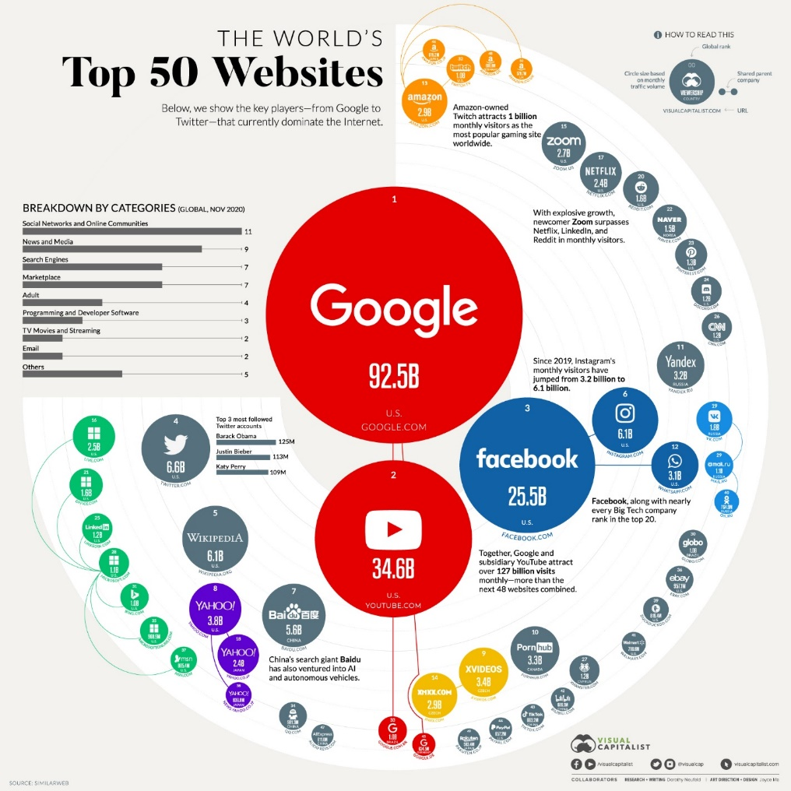

Source of the visual: <https://www.visualcapitalist.com/the-50-most-visited-websites-in-the-world/>

**An example showing how the visual can be explained to the audience in a presentation:**

**[Step 1]** Let’s turn to this diagram which shows the world’s most popular websites as of November 2020. **[Step 2]** The bar chart at the top left shows a breakdown of websites by categories. Here you can see the global rank of the website at the top of the circle, and the circle size is based on monthly traffic volume. **[Step 3]** It is clear that Google, YouTube and Facebook are the top three most visited websites. What’s more, as the pandemic transformed the way we work, learn, communicate and shop, a majority of these activities migrated online. For example, it is not surprising that Zoom has grown explosively, with its number of monthly visitors surpassing Netflix, LinkedIn and Reddit. **[Step 4]** Overall, the data provide evidence to support the argument that social media and news have become part of everyday life of a majority of people worldwide. The data presented gives insight into the industries in which these sites operate and the traffic they attract.

**Practice**

Refer to a journal article in your discipline which includes data visualization. Imagine that you need to explain one of the visuals in the journal article to a group of both technical and non-technical audience in an academic presentation.

* How would you start your explanation?
* How would you guide your audience to understand the data?
* What information will you highlight to the audience?
* How would you explain the significance/meaning of the data?

Follow the steps of explaining data visualization introduced above. Practise explaining the visual to a partner.

|  |
| --- |
| **OPTIONAL TASK - Supplementary Information on Visual Aids for Academic Presentations (Paper Presentations and Poster Presentations)** |

Effective use of visual aids can enhance your presentations. They can increase the audience’s understanding of your topic, make an impact and engage the audience. Visual aids are chosen depending on their purpose. In an academic presentation, power point slides are always used. The following tasks give you some suggestions about the choice of **colouring** and **typographical features** in academic presentations.

**Colouring**

1. Have a look at the four example PPT slides below. Which two slides do you find easier to read? Why?

**There are three effective ways of using multiple colours:**

2.

3.

**Choosing background colours:**

The colours you choose for your foreground and background should be as far apart in value as possible to maximize visibility.

To test various foreground/background combinations, convert your colours to grayscale. The more your two colours approach the values of black and white, the greater the contrast and the clearer your message.

**Using colours to highlight:**

When there is too much information in a slide and you would like to draw the audience attention to certain points, you can use colours to highlight those you will talk about.

Which colour in each diagram do you see immediately?

When multiple colours are present, the audience will tend to see warm colours first.

**Typographical features**

Which slides are easier to read, those on the left or right?

**Rule 1: Never use a single bullet Rule 2: Don’t write wordy bullet items**

Which slides are easier to read, those on the left or right?

**Rule 3: Increase the spacing Rule 4: Indent the text**

Which font do you prefer, Serif or Sans Serif? Why?

1. Sans serif fonts are usually perceived as simple or pure. They are easier to see from a distance. They are best for slide and poster presentations.

1. Serif fonts convey tone and personality and are good for smaller character sizes (10–14 pts) in multiple lines of type.

1. Some sans serif fonts convey a bit more personality than others. They are more playful and can make a presentation seem less standard or routine.

1. Non-proportional (or “monospaced”) fonts are those with each character having the same width. They catch people’s attention easily and are best used in isolation, such as in title slides, flyers.

**Formatting Fonts: Using the Slide Master**

1. Click on **“View”**
2. Then click on “Slide Master”
3. Now click on “Home” to change the font format

After you have finished formatting the fonts, click on **“Slide Master”** and then click **“Close Master View”** to go back to the slides.

**Formatting Consistency across Platforms**

If you use MS PowerPoint on Mac, select Windows-compatible fonts:

If possible, always check on the computer in the room where you are going to present before the presentation.

1. Dudley-Evans, T. (1994). Genre analysis; an approach to text analysis for ESP. In M. Coulthard (Ed.). *Advances in written text analysis* (pp.220-228). London: Routledge.
2. Kanoksilapatham, B. (2015). Distinguishing textual features characterising structural variation in research articles across three engineering sub-discipline corpora. *English for Specific Purposes, 37*, 74-86.
3. Swales, J., & Feak, C. (1994). *Academic writing for graduate students. A course for non-native speakers of English.* Ann Arbor: University of Michigan Press.